How to sign up for Net Control

Open a web browser (MS Edge, Chrome, etc). Type in the club’s web page www.katyars.com
Click on “Net Control Sign Up”. Do not click on Log In under the Account Access section on the right.

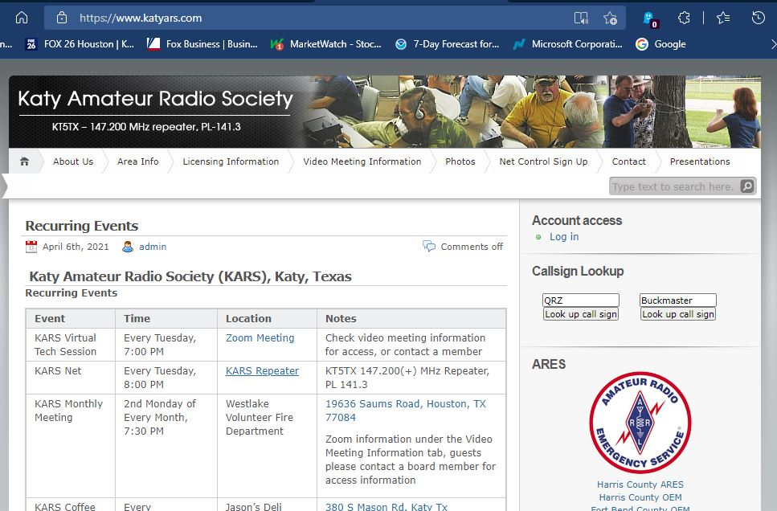
Enter the club’s password (repeater frequency).

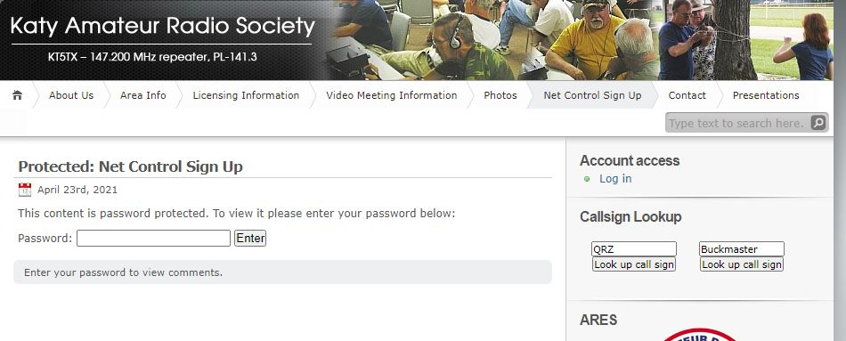
Click on “View & sign-up” for a month that has 1 or more “Open Spots”.

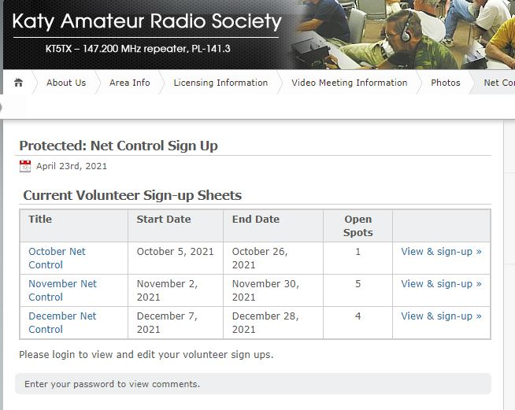

Pick a date that does not have a name already associated with it. Click on “Sign Up”

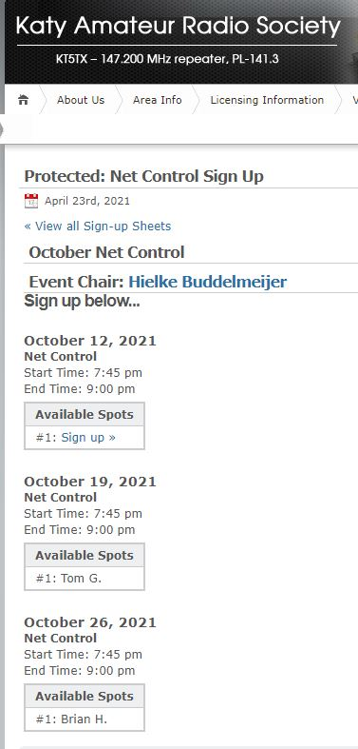

Enter your info into the Sign Up form. Click on the “Sign Me Up” button.

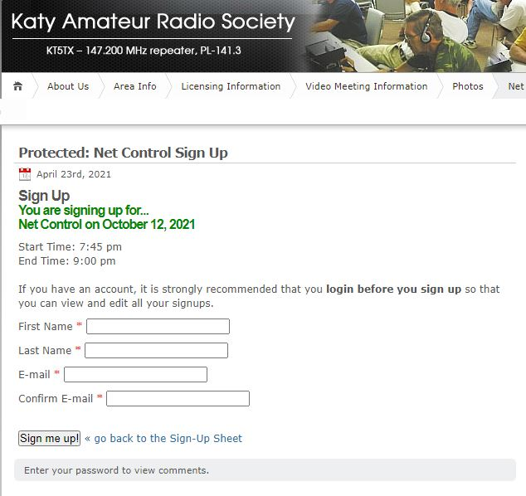

You will get an email confirmation of your sign-up.
The script for the net and log sheet is located in the “About Us”, “Net Control Operator Guidelines” (top of the page).
Keep in mind – this is a hobby – enjoy it !!

